

Submitted by: **SAMEER SHAHID**

Reg No: **SP23-BSE-128 (Section-C)**

Department of Computer Science Comsats University Islamabad, Lahore Campus.

**Api : <https://usmanlive.com/wp-json/api/stories/>**

**Story Management System**

**Get Operation:**

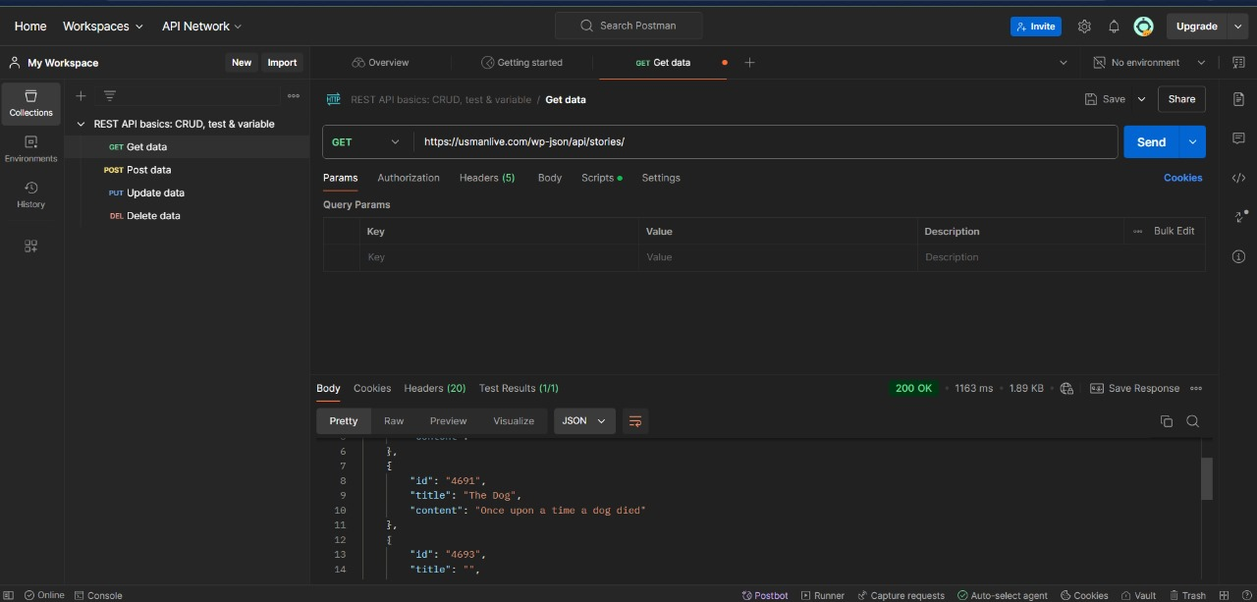

**Put Operation:**

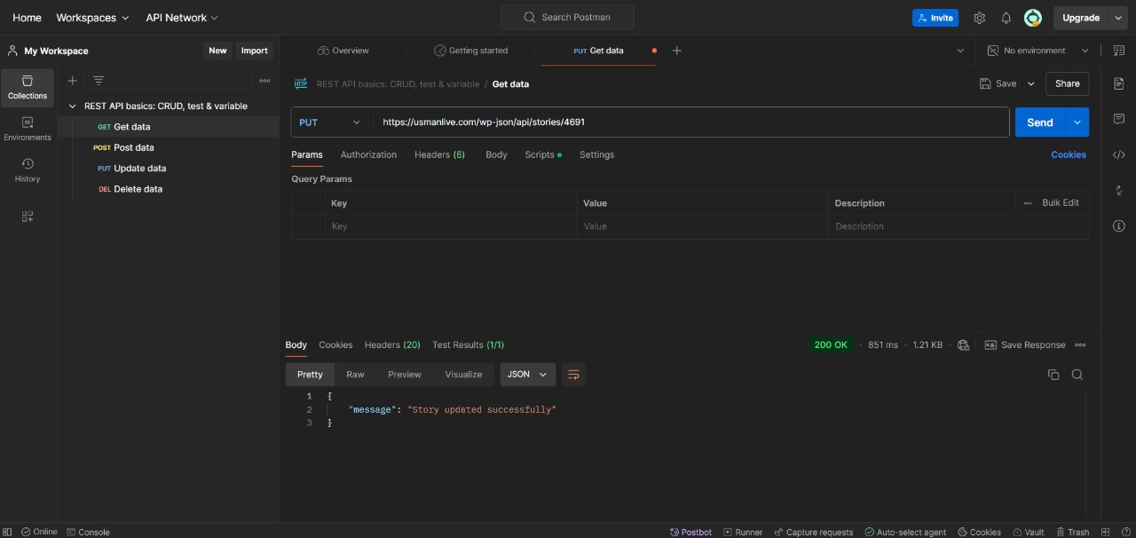

**Delete Operation ;**

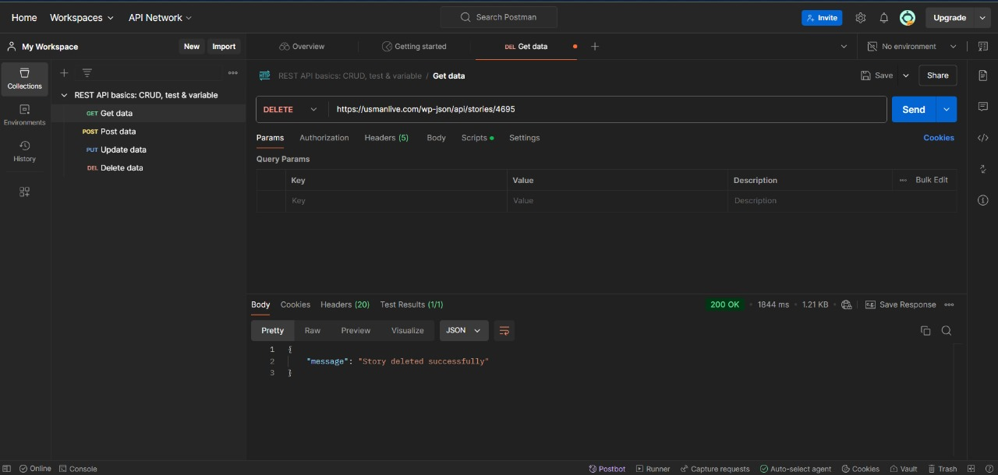

**Post Operation :**

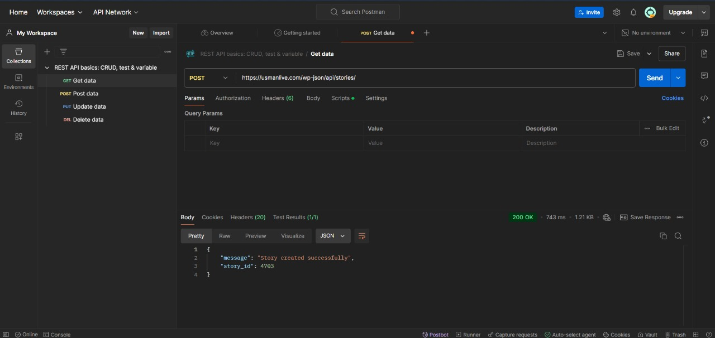

**Frontend of Application**

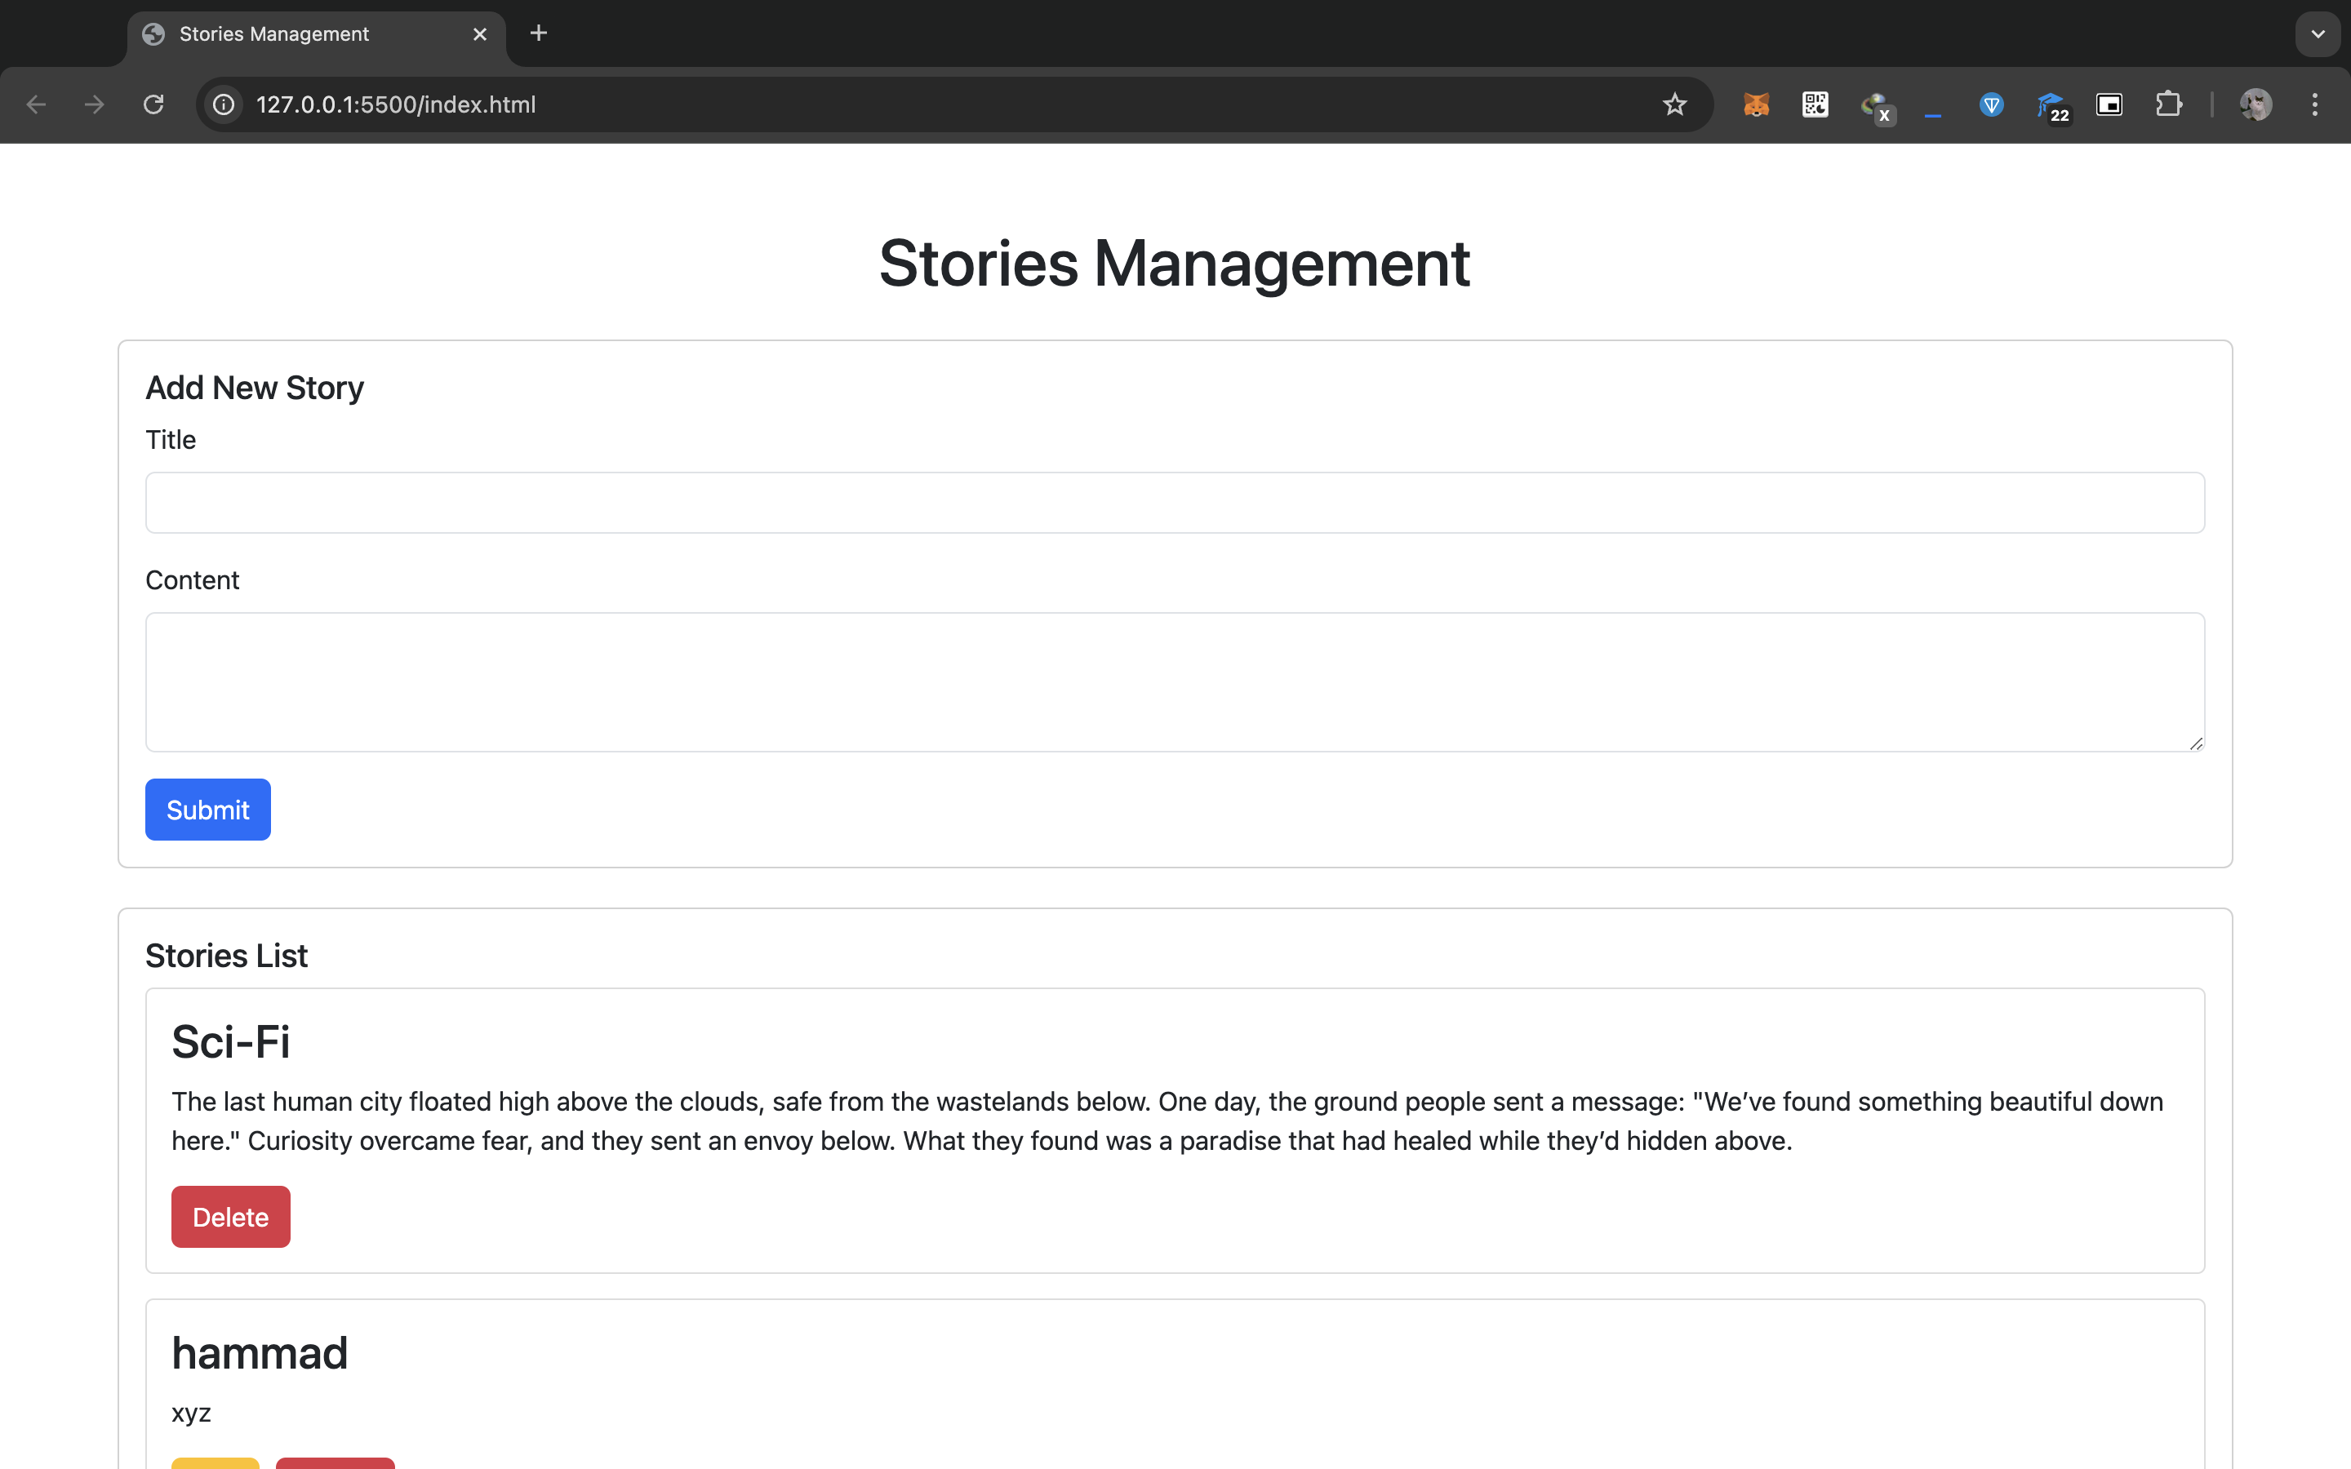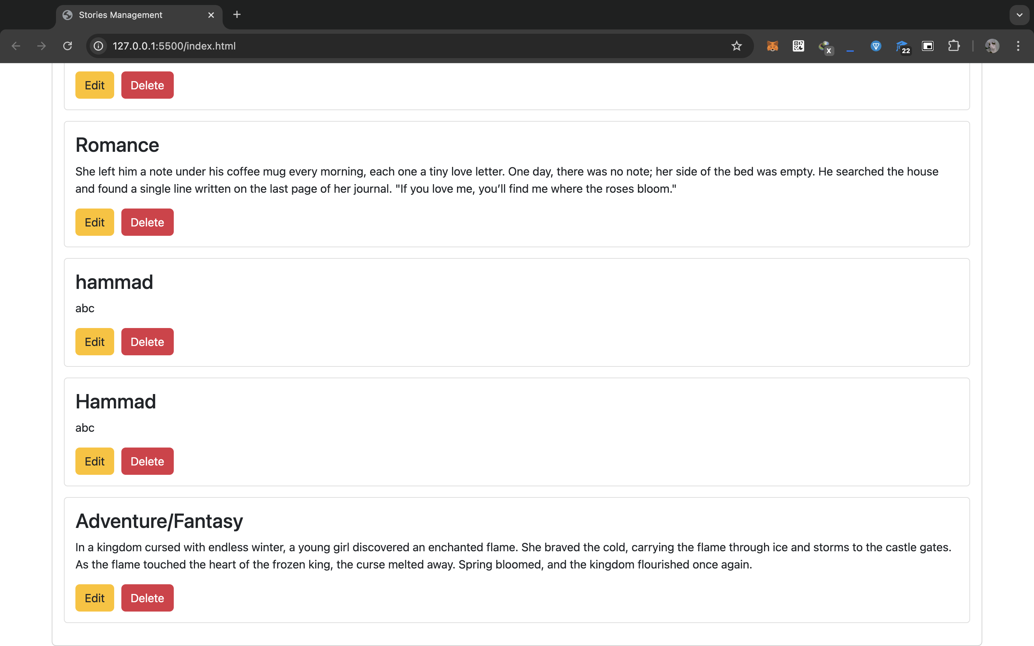

**Files**

**Html**



**Css**



**Js**

